AWS Cloud Practitioner 2022: Technical Essentials Part 2
Cloud computing is an essential skill in today’s workforce and organizations are looking for individuals who can make informed decisions about solutions that meet their business requirements. Learn about the essential AWS services and common solutions available to transform business initiatives. Discover AWS storage and database services and compare benefits of AWS storage types, including Amazon Elastic Block Store (EBS) and Amazon S3. Explore the Amazon database offerings Relational Database Service (RDS) and DynamoDB. Finally, investigate the best practices and tools for monitoring and optimization in AWS. This course is one of a collection that prepares learners for the AWS Certified Cloud Practitioner 2022 certification.
Table of Contents
1. Video: Course Overview (it_clawsp22_02_enus_01)
2. Video: AWS Storage Types (it_clawsp22_02_enus_02)
3. Video: Exploring Amazon Elastic Block Store (EBS) (it_clawsp22_02_enus_03)
4. Video: Object Storage with Amazon S3 (it_clawsp22_02_enus_04)
5. Video: Databases in AWS (it_clawsp22_02_enus_05)
6. Video: Amazon Relational Database Service (RDS) (it_clawsp22_02_enus_06)
7. Video: Amazon DynamoDB (it_clawsp22_02_enus_07)
8. Video: Monitoring in AWS (it_clawsp22_02_enus_08)
9. Video: Optimization in AWS (it_clawsp22_02_enus_09)
10. Video: Course Summary (it_clawsp22_02_enus_10)
1. Video: Course Overview (it_clawsp22_02_enus_01)
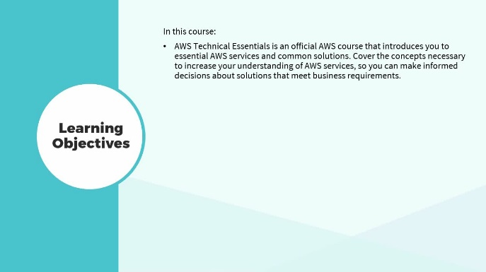
In this video, discover the key concepts covered in this course.
- discover the key concepts covered in this course
[Video description begins] Topic title: Course Overview. Your host for this session is Michael J. Shannon. [Video description ends]
AWS Technical Essentials is an official AWS course that introduces you to essential AWS services and common solutions. The course covers the concepts necessary to increase your understanding of AWS services, so you can make informed decisions about solutions that meet business requirements. In this course number two the learner will explore AWS storage and databases, monitoring and optimization.
2. Video: AWS Storage Types (it_clawsp22_02_enus_02)
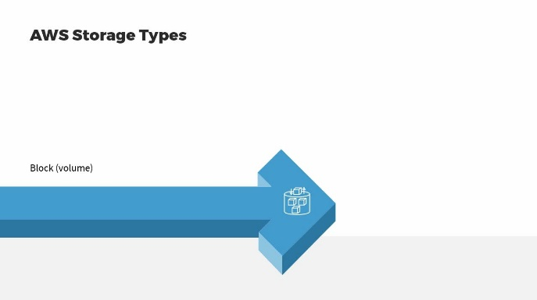
To compare AWS storage types, follow these steps:
- compare AWS storage types
[Video description begins] Topic title: AWS Storage Types. Your host for this session is Michael J. Shannon. [Video description ends]
In this first lesson of Technical Essentials part 2, we're going to look at one of the main storage types of Amazon Web Services. Now, remember there's two main types of storage. There's block or volume storage, which is basically network storage virtualized from arrays of hard disk drives and solid-state drives. Then there's object storage or blob storage. We'll talk about that in the next lesson.
Block or volume storage is a low-level technology that supports most modern data storage. If you think about your workstation, your PC, your laptop, your USB drive, your FireWire drive, storage for RAID arrays, databases, and other technologies, you're often using block or volume storage. Where you're dividing data into small units called blocks. This provides fast and flexible ways to manage data using file systems. So, for example, on your Windows system you'll be using CIFS or the Common Internet File System. Unix and Linux have other choices for file systems depending upon your build.
A block storage volume is an assembly of blocks; each with a unique identifier, and each can be read and written independently. Block storage is any storage that keeps data in block storage volumes and is ideal for local storage and high-performance transactional workloads such as databases. Any activities that have lots of read/writes or high IOPS or input/output per second demands. So, for example, once you pass this exam, let's say you're going to change your resume, which is stored in block storage or volume storage. You'll use your file system, you'll go down and you'll open up that file, you're bringing that up into RAM memory and you'll make your changes to it.
For example, in the certifications area, adding your AWS Cloud Practitioner certification, then you can save the file. With block storage, you don't have versioning, so it's one of the different version of the file you have to rename it, you can have two files with the same name in a volume. You also have very limited metadata about that file, and it depends on your operating system. Now, in the next lesson, I'll do a demonstration of Amazon Web Services Elastic Block Storage service. Looking at it from a couple of perspectives. One, when instantiating an image and two, in the EBS service itself.
3. Video: Exploring Amazon Elastic Block Store (EBS) (it_clawsp22_02_enus_03)
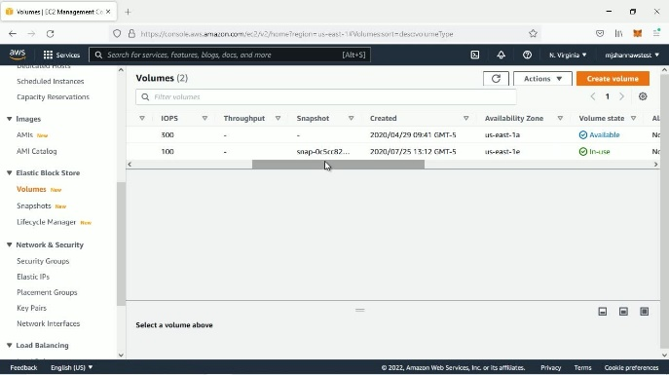
Learn how to navigate Amazon's Elastic Block Store (EBS).
- explore Amazon Elastic Block Store (EBS)
[Video description begins] Topic title: Exploring Amazon Elastic Block Store (EBS). Your host for this session is Michael J. Shannon. [Video description ends]
OK, I'm up at the EC2 area of AWS. The Elastic Compute Cloud on the EC2 dashboard.
[Video description begins] An aws page appears. The bar at the top displays a search toolbar and a drop-down button named N. Virginia. The left navigation pane displays various options under the heading New EC2 Experience. Their names are: EC2 Dashboard, EC2 Global View, Events, Tags, and Limits. The EC2 Dashboard option is highlighted. Below, it displays various options under the following headers: Instances, Images, Elastic Block Store, and Network & Security. The main pane displays two sections: Resources and Launch instance. [Video description ends]
The first thing I'm going to do is I want to scroll down here on the left-hand side to the Elastic Block Store area where we can see Volumes,
[Video description begins] The Elastic Block Store header on the left displays the following options: Volumes, Snapshots, and Lifecycle Manager. [Video description ends]
click on that and we'll notice that I have two volumes already.
[Video description begins] A subsequent page opens titled Volumes (2). It contains a table that has various column headers, such as, Name, Volume ID, Type, Size, IOPS, Throughput, Snapshot, Created, Volume state, Alarm status, Attached Instances, and Encryption. The page also has a button named Create volume. [Video description ends]
They have unique IDs, they have the Type gp2. One is a 100 GiB in Size with 300 IOPS, the other is 30 gigabytes in Size with a 100 IOPS. A snapshot, by the way, is taking the information on this virtual volume and actually putting it into object storage.
Creating a snapshot of it, and it shows when there's actually created here. These are going to be in a region, for example, there are the N. Virginia region. They're also deployed into Availability Zones. This ones in zone 1a, the first zone, and this is in 1e, the sixth zone. There's 6 Availability Zones in N. Virginia. You can see that this one is attached to an instance, Not encrypted. This one is not attached, so, that's one thing about in the Elastic Block Store will click on Create volume as you can create it ahead of time and then you don't have to attach it.
[Video description begins] A page titled Create volume appears. It contains two sections named Volume settings and Tags. The first section further contains the following fields: Volume type, Size, Availability Zone, and Snapshot ID. [Video description ends]
If you do attach it and you stop or you delete the instance of Windows or macOS or Linux, you don't lose the data on the volume. That's really why it's called Elastic.
You can see there's different Volume types. Two General Purpose types, two high end provisioned IOPS, solid state drives in older Cold HDD and a Throughput Optimized HDD. Depending on your choice you can choose the Size from 1 GiB to a maximum of 16384 gigabytes and then depending on what Volume type you choose, you have different IOPS and you can deploy it into an Availability Zone. You can say Don't create a volume from a snapshot or you can go ahead and specify a snapshot ID, if you want to do that here. And again, remember this is object storage, we'll talk more about object storage in the next lesson.
We have the ability to Encrypt this volume here, 20 AES-256-GCM, and then typically you're going to label things and tag things.
[Video description begins] The Tags section displays a button called Add tag. [Video description ends]
It's usually a good idea to have a key-value pair in some type of schema, and that you tag everything for change and configuration management as part of that change control initiative.
[Video description begins] As he clicks the Add tag button, two fields appear. They are: Key and Value. [Video description ends]
So, that's creating a volume here in the Elastic Block Store area.
But you can also go back to the dashboard and when you Launch an instance.
[Video description begins] He returns to the EC2 Dashboard page. The Launch instance section contains two buttons named Launch instance and Migrate a server. The Launch instance drop-down menu displays two options: Launch instance and Launch instance from template. [Video description ends]
As we'll do here, we'll do the Linux 2 AMI.
[Video description begins] A new page opens that displays the following tabs: Choose AMI, Choose Instance Type, Configure Instance, Add Storage, Add Tags, Configure Security Group, and Review. The first tab displays a list of various options under the heading: Step 1: Choose an Amazon Machine Image (AMI). The first option name is Amazon Linux 2 AMI (HVM) - Kernel 5.10, SSD Volume Type. It contains a button named Select. [Video description ends]
We'll choose the t2.micro from the free tier eligible.
[Video description begins] The next tab page opens, named Step 2: Choose an Instance Type. It contains a table that displays the following headers: Family, Type, vCPUs, and Network Performance. [Video description ends]
We'll say Configure Instance Details and we'll just stick with the defaults
[Video description begins] The Step 3: Configure Instance Details page opens. It comprises various fields: Number of instances, Purchasing option, Network, Subnet, and DNS Hostname. [Video description ends]
here and then go Add Storage. So, you can see we have a root volume and it's got a Snapshot automatically.
[Video description begins] Step 4: Add Storage page appears. It displays a table with the following column headers: Volume Type, Device, Snapshot, Size(GiB), Volume Type, and Encryption. It contains the Add New Volume button. [Video description ends]
It's 8 gigs in Size and it's from the General Purpose SSD, and it's not encrypted, so I could add a new volume here or if I wanted to, I could just skip that step and then go ahead and add the tags and launch it and then attach an existing block store volume to this Linux instance after the fact. OK, if I add new volume, this particular image only supports the Elastic Block Store type of block storage.
You can see I've got those same options I showed you earlier and we can then choose to encrypt or Not Encrypt.
[Video description begins] The Volume Type header displays the following options: General Purpose SSD (gp2), General Purpose SSD (gp3), Provisioned IOPS SSD (io1), and Cold HDD (sc1). [Video description ends]
And if I want to I can go ahead and choose an existing key in the key management system if I want to do that and I have one here.
[Video description begins] A cutout appears on the screen. It displays a list of options under two headers: KMS Key Aliases and KMS Key ID. [Video description ends]
So, that is the Elastic Block Store option remember when you add this storage to your instance, in this case a Linux 2 instance. If you stop or terminate the instance, you do not lose the volume or the actual data.
There's another kind of drive. If you go back to EC2 area, if we go down to Images AMIs.
[Video description begins] A page titled Amazon Machine Images (AMIs) appears. It contains a table that has the following column headers: Name, AMI ID, AMI name, and Source. [Video description ends]
You can see that we can create or choose our own Amazon Machine Image, and some of these images can actually use what's called ephemeral instance store, an ephemeral instance storage is directly attached at the hypervisor. It's going to be a solid state drive and it's going to be very high speed, it's for high-performance computing with an ephemeral instance drive, however, if you stop or terminate the instance, you lose the data on the drive. So, it's used for, you know, high-performance calculations, creating lots of temporary files, log files, things like that. Alright so, that is the EC2 experience and Elastic Block Storage (EBS).
4. Video: Object Storage with Amazon S3 (it_clawsp22_02_enus_04)
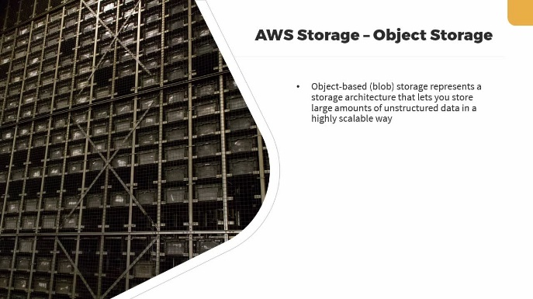
In this video, you will learn how to define object storage using Amazon S3.
- define object storage with Amazon S3
[Video description begins] Topic title: Object Storage with Amazon S3. Your host for this session is Michael J. Shannon. [Video description ends]
Our second main storage type, which is the second category in the storage core offering is object storage. Object-based or as other providers call it blob storage represents a storage architecture that lets you store large amounts of unstructured data in a highly scalable way. At AWS the main object storage service is Simple Storage Service or S3. Will explore that in greater detail in an upcoming course.
In object-based storage devices or systems, there are no folders, directories, files, or hierarchies that you would normally use in a file-based system. These systems store all data in a flat data environment as the objects are accessed not by a file system like CIFS or NFS, but by URLs and API calls or API requests. Each object contains the data itself, some descriptive information associated with that object which we call metadata, and a globally unique identifier.
So, to compare storage types on the right-hand side, we're talking about object storage, where data is stored as 'objects' in scalable 'buckets' in Amazon Web Services, ideal for unstructured big data, analytics and archiving. Now, if the data is archived, it'll be stored in a vault specifically, AWS glacier vaults.
Moving to the left, we see files. Data stored as 'files' in a hierarchically nested 'folder' ideal for active documents. Keep in mind, however, that file storage is actually block or volume storage, put it AWS.
For Linux instances, you can use the Elastic File Service which can grow to petabyte sizes and you only pay for the space you use. And then, of course, block or volume storage where data is stored in fixed-size 'blocks' in a rigid arrangement accessed by different file systems and is ideal for enterprise databases. High read, write operations and high-performance computing (HPC).
5. Video: Databases in AWS (it_clawsp22_02_enus_05)
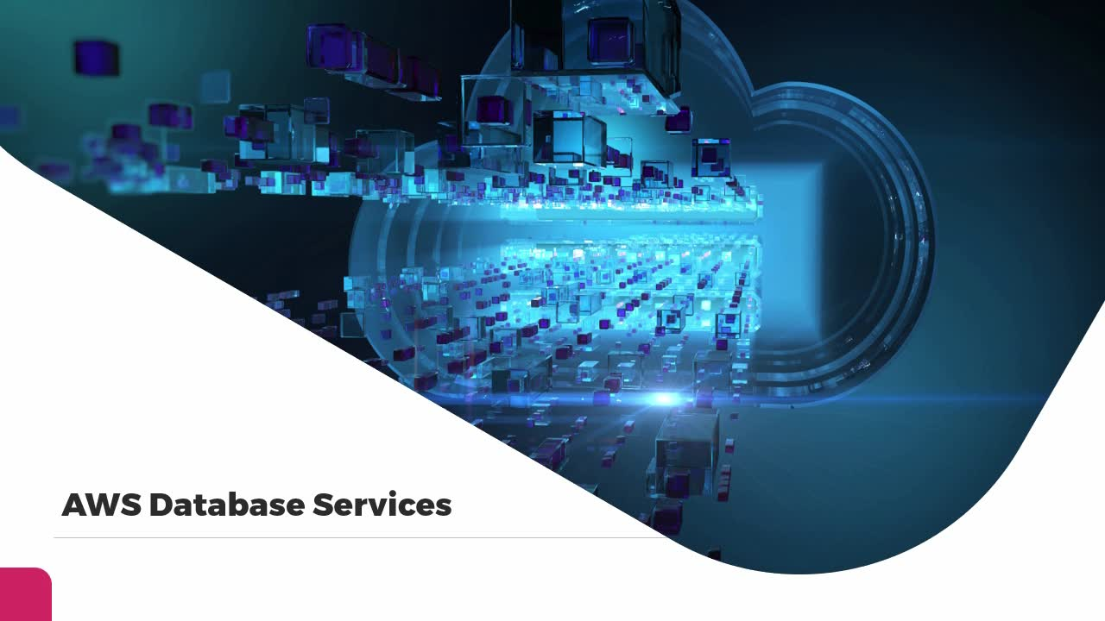
During this video, you will learn how to compare AWS database services.
- compare AWS database services
[Video description begins] Topic title: Databases in AWS. Your host for this session is Michael J. Shannon. [Video description ends]
In this brief lesson, we're going to cover the database services of Amazon Web Services and realize we're going to dig deeper into databases when we get to course 9. So, I don't want to steal too much thunder from that particular course. I want to focus here on the database types and their use cases. When we get to course 9, we'll dig deeper into the different AWS services.
So, first off, we have relational databases. These stored data with pre-defined schemas and relationships by joining tables and these are used for traditional applications, databases, enterprise resource planning (ERP), customer relationship management (CRM), and e-commerce. Next we have key-value databases. These are optimized for common access patterns, often storing and retrieving large volumes of data. These are for high-traffic web applications, e-commerce systems and gaming applications.
Next we have in-memory databases. These are used for applications that need real time access to data for example, microsecond latency. Things like caching, session management, gaming leaderboards, and geospatial applications. Then we have document databases. This is designed to store semi-structured data as JSON like documents. These databases help developers build and update applications quickly. They're used for content management, catalogs and user profiles.
A wide column database is a type of NoSQL database. It uses tables, rows and columns. But unlike a relational database, the names and format of the columns can vary from row to row in the same table. We use wide column database types for a high-scale industrial apps for equipment maintenance, fleet management, and route optimization. Graph databases, use nodes, and these are for applications that need to navigate and querying millions of relationships between highly connected datasets with millisecond latency at a large scale. It's used for fraud detection, social engineering and recommendation engines.
A time series database will efficiently collect, synthesize, and derive insights from data that change overtime. We use this for IoT Internet of Things applications, DevOps and industrial telemetry. Finally, a Ledger database offers a centralized and trusted authority to maintain a scalable, immutable and cryptographically verifiable record of transactions for every application used for systems of record, supply chain registration, banking transactions, insurance claims and more. In other words, Blockchain technology.
6. Video: Amazon Relational Database Service (RDS) (it_clawsp22_02_enus_06)
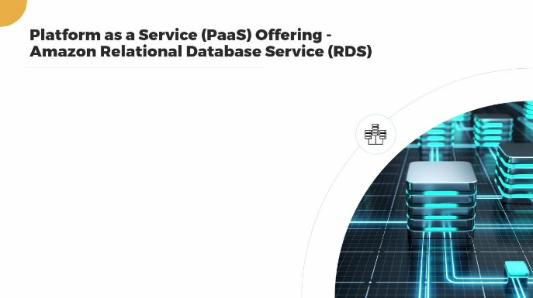
In this video, you will learn how to define Amazon Relational Database Service (RDS).
- define Amazon Relational Database Service (RDS)
[Video description begins] Topic title: Amazon Relational Database Service (RDS). Your host for this session is Michael J. Shannon. [Video description ends]
When we think about Platform as a Service at Amazon Web Services, we often think about doing our DevOps, our application development, our containers, our traditional web services, microservices. But relational database services are another very popular platform as a service offering. RDS is a managed service for setting up, operating and scaling a cloud-based relational database. It's available on several database instance types that are optimized for memory, performance, or input/output or I/O.
You can choose from PostgreSQL, MySQL, MariaDB, Oracle Database, SQL Server, and the fully-managed Amazon Aurora. You can also use the AWS Database Migration Service to migrate or replicate your existing databases to RDS. In fact, many organizations install the AWS Storage Gateway at their premises or in their data center to facilitate this migration or movement of data to the RDS.
Amazon Aurora is the fully-managed AWS RDS service. Your options are MySQL and PostgreSQL compatible relational database engines. The cost to start is less than $1.00 a day. You get up to 64 terabytes of auto-scaling storage capacity, including 6-way replication across three availability zones by default. And Amazon Aurora recently has provided a server less solution as well, running MySQL or Postgres without underlying servers. Basically, on the AWS data center infrastructure.
7. Video: Amazon DynamoDB (it_clawsp22_02_enus_07)
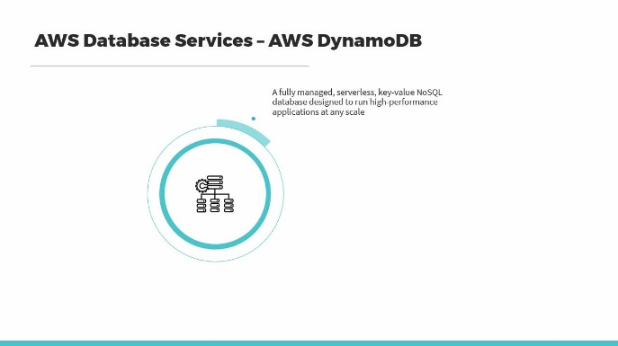
Discover how to define the Amazon DynamoDB service.
- define the Amazon DynamoDB service
[Video description begins] Topic title: Amazon DynamoDB. Your host for this session is Michael J. Shannon. [Video description ends]
2004 was a banner year for online shopping and that year during the holidays Amazon.com had a lot of issues with their underlying database. So, in 2005 they decided to build a new database for the online retailer. And that's where DynamoDB was born. DynamoDB is a fully managed, serverless, key-value NoSQL database designed to run high-performance applications at any scale. The fast, flexible NoSQL database service offers single-digit millisecond performance at any scale. It offers built-in security using AES-GCM-256, continuous backups, automated multi-region replication, in-memory caching using Redis and data export tools. DynamoDB is used by thousands of AWS customers all over the world.
Here we see an example workflow of using DynamoDB. First, you can configure key features leveraging the built-in security, backup and restore, flexible capacity modes, multi-region replication, in-memory caching, data modeling tools and more. Then from DynamoDB you can export, analyze and stream data. You can also integrate with other AWS services by exporting table data to perform analytics and extract insights or monitor trends and logs for enhanced security.
Using services like Amazon S3 object storage, AWS Glue Elastic Views. AWS Glue is a serverless data integration service that allows you to discover, prepare, and combine data for analytics, machine learning and application development. DynamoDB can send data to Amazon Kinesis Data Streams. Kinesis allows you to ingest, buffer and process streaming data in real time, allowing you to derive insights in seconds or minutes as opposed to hours or days.
Kinesis is a fully managed service and it runs your streaming applications without demanding that you manage any infrastructure. You can send data to AWS CloudTrail, where you monitor and record account activity across your AWS infrastructure. Basically, analyzing all of your API calls or API requests or to Amazon CloudWatch, your global monitoring and visibility tool.
8. Video: Monitoring in AWS (it_clawsp22_02_enus_08)
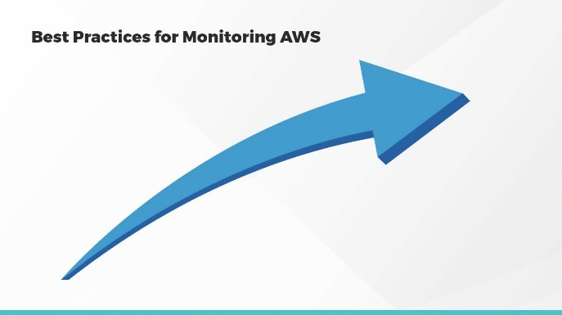
In this video, you will learn best practices and tools available for monitoring in AWS.
- recall best practices and tools available for monitoring in AWS
[Video description begins] Topic title: Monitoring in AWS. Your host for this session is Michael J. Shannon. [Video description ends]
When you think about one of the main challenges of cloud computing, it's the fact that the data center in the various availability zones in different regions are not at your disposal. In fact, it's rare that you would actually, as a customer, be able to enter an AWS data center. It's a highly secure environment. Most employees of Amazon, and even many AWS employees will never get into in AWS data center, so it's critical that we use all the tools available for monitoring and visibility of our AWS cloud resources.
So, in the beginning in the planning phases, designate your monitoring objectives. Monitor all aspects of cloud usage whenever feasible. Always leverage automation when available. Start with basic native cloud monitoring tools and build from there and always use an established tagging schema to improve accountability. Whatever schema you use for tags at AWS should map to your overall configuration and change control management or your CMDB, your configuration management database. You can also leverage organizations like CSA, the Cloud Security Alliance or the CIS, Center for Internet Security to help you with guidelines, baselines, and best practices for cloud usage. In addition, you can use the CSA with their control matrix as a global cloud auditing tool.
At AWS you can use CloudWatch, a native monitoring tool to gather actionable insights and meaningful metrics for all of your AWS workloads. There's CloudTrail which monitors and records account activity across the AWS infrastructure, offering control over storage, analysis and remediation actions. Basically, all of the restful API calls and requests that are made in the AWS cloud.
There's AWS Config, a tool you can use to assess, audit, and evaluate all the configurations of your AWS resources. These are often expressed in JSON or YAML format as you evaluate infrastructure as code. And the AWS Security Hub, this provides IT teams with a single console to aggregate and prioritize security alerts from multiple security services like AWS GuardDuty, AWS inspector and AWS Shield Standard and Shield advanced.
AWS CloudTrail is one of your main monitoring tools that records user activity and API usage in AWS services. You can store by delivering events to AWS S3 and CloudWatch Logs. You can monitor to detect unusual API activity, for example, unauthorized instantiation of instances or security events. You can do this through CloudTrail insights or you can use Amazon EventBridge. Amazon EventBridge is a serverless event bus that makes it easy to build event driven applications at scale, using events generator from your applications. This is basically an integrated Software as a Service application.
After it targets AWS Lambda functions and then analyze view recent events in the AWS CloudTrail console, or analyze log files with Amazon Athena. Athena is an interactive query service that makes it easy to analyze data in S3 using standard SQL. It's serverless, so, there's no infrastructure to manage, and you only pay for the queries that you run. So, use AWS CloudTrail to audit, for security monitoring, and for operational troubleshooting.
9. Video: Optimization in AWS (it_clawsp22_02_enus_09)
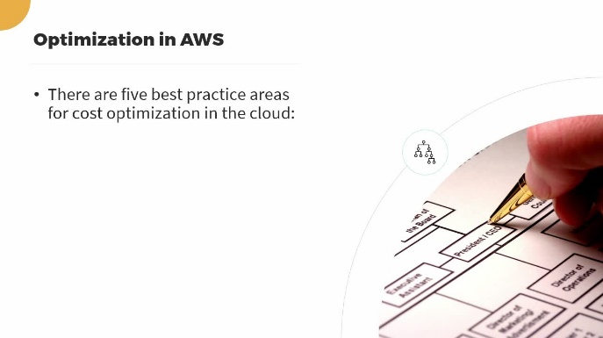
After completing this video, you will be able to recall best practices and tools available for optimizing AWS.
- recall best practices and tools available for AWS optimization
[Video description begins] Topic title: Optimization in AWS. Your host for this session is Michael J. Shannon. [Video description ends]
In our final lesson, we'll look at optimization in Amazon Web Services. There are five best practice areas for cost optimization in the cloud. Now, realize there are other ways to optimize. For example, optimizing your auto-scaling or optimize access to services by using endpoints as opposed to internet gateways. But your first order of business when using a cloud provider is the optimize your costs. So, you want to practice cloud financial management, sound management. You want to utilize expenditure and usage awareness. Make sure the resources you deploy are cost-effective. Manage demand and supply resources and optimize continually over time or continual improvement.
Some common optimization tools at AWS would be the AWS Trusted Advisor. This offers recommendations that help you follow AWS best practices. It evaluates your account by using checks. These checks help you improve security and performance, reduce costs, and monitor your service limits or quotas. The AWS Cost Explorer is a tool that helps you visualize, understand and manage your AWS costs and usage over a daily or monthly timeframe. You can also dig deeper using granular filtering and grouping dimensions such as usage type and tags.
Amazon QuickSight allows everybody in your organization to understand your data. And it does this by asking questions in natural language, so, exploring through interactive dashboards or looking for patterns and outliers automatically powered by machine learning algorithms. So, from an optimization standpoint, you can combine the machine learning power of QuickSight with your Cost and Usage Report or the CUR. We can use the aforementioned AWS CloudWatch for monitoring and optimizing your auto-scaling groups. You can optimize your organizations into organizational units and manage this with AWS Control Tower.
AWS Control Tower is a straightforward way to set up and govern, and AWS multi account environment. It also gives you best practices and allows you to orchestrate the capabilities of several other AWS services including AWS organizations. Finally, there's the IAM Access Analyzer, which uses a proprietary machine learning engine to help you identify the resources in your organization and accounts. For example, looking at IAM roles or S3 buckets, it offers provable security to analyze all access paths and offer a comprehensive analysis of external access to all of your resources.
10. Video: Course Summary (it_clawsp22_02_enus_10)
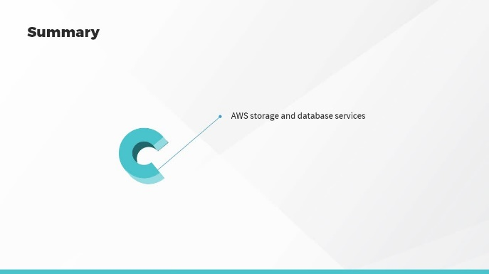
In this video, we will summarize the key concepts covered in this course.
- summarize the key concepts covered in this course
[Video description begins] Topic title: Course Summary [Video description ends]
In this course, we looked at AWS storage and database services. Monitoring in Amazon Web Services and AWS optimization. In the next course, we'll explore the AWS cloud value proposition.
© 2025 Skillsoft Ireland Limited - All rights reserved.

